Impactful dialogues at #InvestopiaGlobal – #Alberta in #Calgary, driving the next wave of cross-border investment.
Honored to meet global leaders:
· Jean Charest – 29th #Premier of #Quebec & Co-Chair, Canada–UAE Business Council
· H.E. Abdulla Bin Touq – #UAE #Minister of Economy & Chairman of Investopia
· H.E. Dr. Dr. Thani Al Zeyoudi – #UAE #Minister of State for Foreign Trade
· The Hon. Danielle Smith – #Premier of Alberta
· Joseph Schow – Alberta Minister of Jobs, Economy, Trade & Immigration
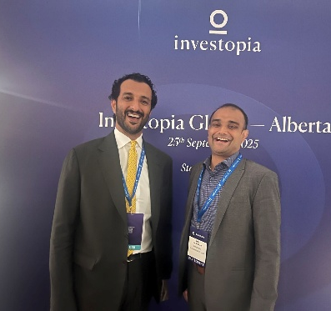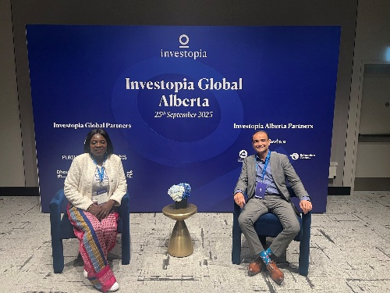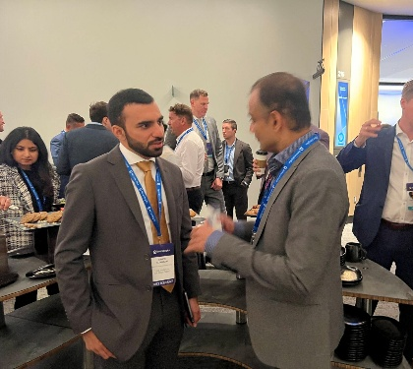
Proud of our participating teams — #ConsultingPlanet, #PanAmerInd, #PowerIntegral, and #AscendiaConsulting (Colombia)— with our focus in advancing a transversal business model that integrates #capital, #technology, and #policy across regions to catalyze large-scale projects.
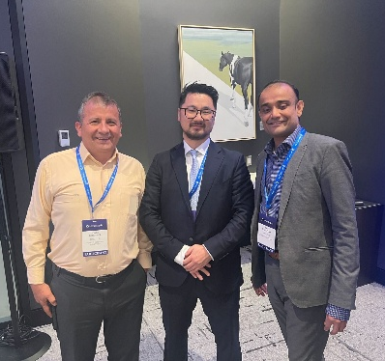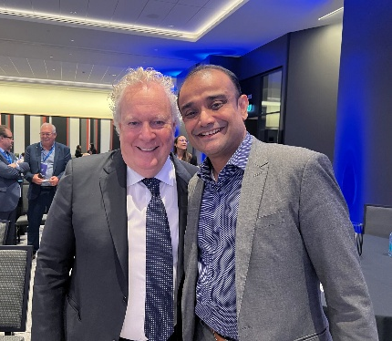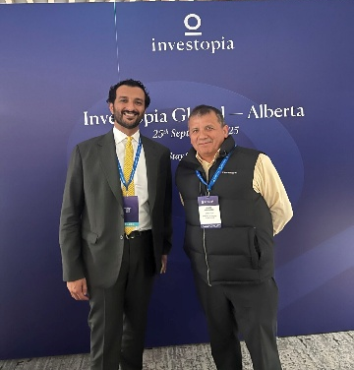
Our #NorthAmerica – #LatAm – #MiddleEast – #India Nexus accelerates :
· #FDI in #IT & #DigitalInfrastructure: strategic investments in #Dubai’s National Industries Park & Dubai Internet City.
· #Energy & #CleanTech in #Alberta: investments in #oil, #gas, #hydrogen, #CarbonCapture, and #ESG-aligned innovation.
· #TransversalLeverage: one platform mobilizing investment flows — #Dubai ↔ #Alberta ↔ #Bogotá.
We believe bridging jurisdictions and industries is no longer optional — it is the future. That’s why we are:
· Facilitating #AnchorInvestors who see value in #TransContinentalEcosystem plays
· Structuring multipolar deals that connect #Dubai, #Calgary, and the potent #LatAm value chain
· Embedding #Sustainability, #Innovation, and #FutureReadiness into every project
Together, we are building a new paradigm for cross-border, cross-sector FDI. Excited to continue shaping it with partners who share this vision.
#Investopia #FDI #TechEcosystems #EnergyTransition #CrossBorderInvestment #Dubai #UAE #Alberta #LatAm #India #ConsultingPlanet #PanAmerInd #AscendiaConsulting #PowerIntegral
David Lederhendler, Kemi Bolatito, Jorge Bermudez, Marta Lucía Nuñez Orlando Bermúdez Milanes, Harvey Barrios, Raul Hernan Olguin Triviños

